**Homework – Employee evaluations, dealing with employee conflict**

Option 1: Employee evaluation and assessment (from: Pymm & Hickey, 2007, p.99)

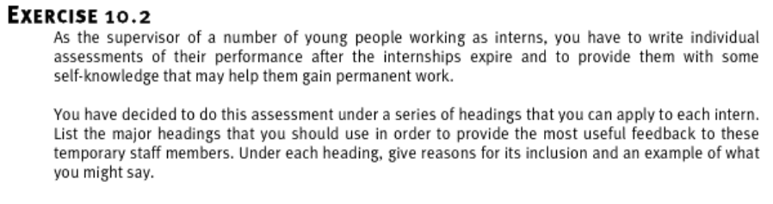

Use any of the resources provided, or other sources you find yourself, to create an evaluation template you could use to provide feedback to interns in your department. Presume this is a mid-placement review for a 6-month placement, and there will be another review at the end of the placement. Cite at least one source you used to help you decide which headings to use. Cite the source at the end of your answer. **Submission length should be approximately 100-200 words or 30-60 seconds.**

If you would prefer a *different* employee performance situation, you may use one of the ones below instead. In these case studies, how would you, as the supervisor, deal with the conflict regarding performance feedback?

[Vasundhara’s Appraisal](https://sk-sagepub-com.dproxy.library.dc-uoit.ca/cases/vasundharas-appraisal)

[Beauty and the Beastly Situation at Aerospace Designs' Marketing Department](https://sk-sagepub-com.dproxy.library.dc-uoit.ca/cases/download/beauty-beastly-situation-aerospace-designs-marketing-department?format=case)

Suggested resources:

Pymm, B., & Hickey, D. (2007). Learn Library Management: A Practical Study Guide for New or Busy Managers in Libraries and Other Information Agencies. TotalRecall Publications. <https://ocul-it.primo.exlibrisgroup.com/permalink/01OCUL_IT/as9o6s/cdi_proquest_ebookcentral_EBC3410625> see pages 98-101

Raines, S. (2013). Conflict Management for Managers: Resolving Workplace, Client, and Policy Disputes. John Wiley & Sons, Incorporated. <https://ocul-it.primo.exlibrisgroup.com/permalink/01OCUL_IT/as9o6s/cdi_askewsholts_vlebooks_9781118418420> *This one is very in-depth, and is useful if you want detailed information or plan to choose HR for your research assignment topic. Of course, you can skip to the relevant sections in part 2 for this assignment.*

Option 2: Case study - (from: Pymm & Hickey, 2007, p.102)

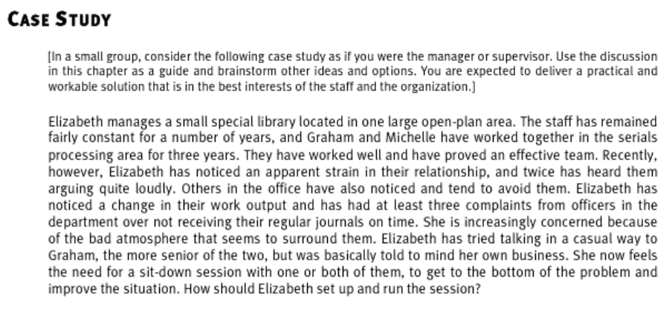

Use any of the resources provided, or other sources you find yourself, to write or record how you would deal with the situation if you were the supervisor. Cite at least one source you used to help you decide how to deal with the situation. Cite the idea(s) in-text and cite the entire source at the end of your answer. **Submission length should be approximately 200-250 words or 30-60 seconds.**

Suggested resources:

Karahalios, Dylan. Performance management 6 simple steps. (2010). Youtube. Retrieved 6 February, 2021 from <https://youtu.be/IHpAacOQTk0>

Pymm, B., & Hickey, D. (2007). Learn Library Management: A Practical Study Guide for New or Busy Managers in Libraries and Other Information Agencies. TotalRecall Publications. <https://ocul-it.primo.exlibrisgroup.com/permalink/01OCUL_IT/as9o6s/cdi_proquest_ebookcentral_EBC3410625> see pages 98-101

Raines, S. (2013). Conflict Management for Managers: Resolving Workplace, Client, and Policy Disputes. John Wiley & Sons, Incorporated. <https://ocul-it.primo.exlibrisgroup.com/permalink/01OCUL_IT/as9o6s/cdi_askewsholts_vlebooks_9781118418420> *This one is very in-depth, and is useful if you want detailed information or plan to choose HR for your research assignment topic. Of course, you can skip to the relevant sections in part 2 for this assignment.*